Raymond You and Julian

EECE 2160 - Kimani 8 AM

Lab 9: Simulink + Robotic Arm

# Assignment 1

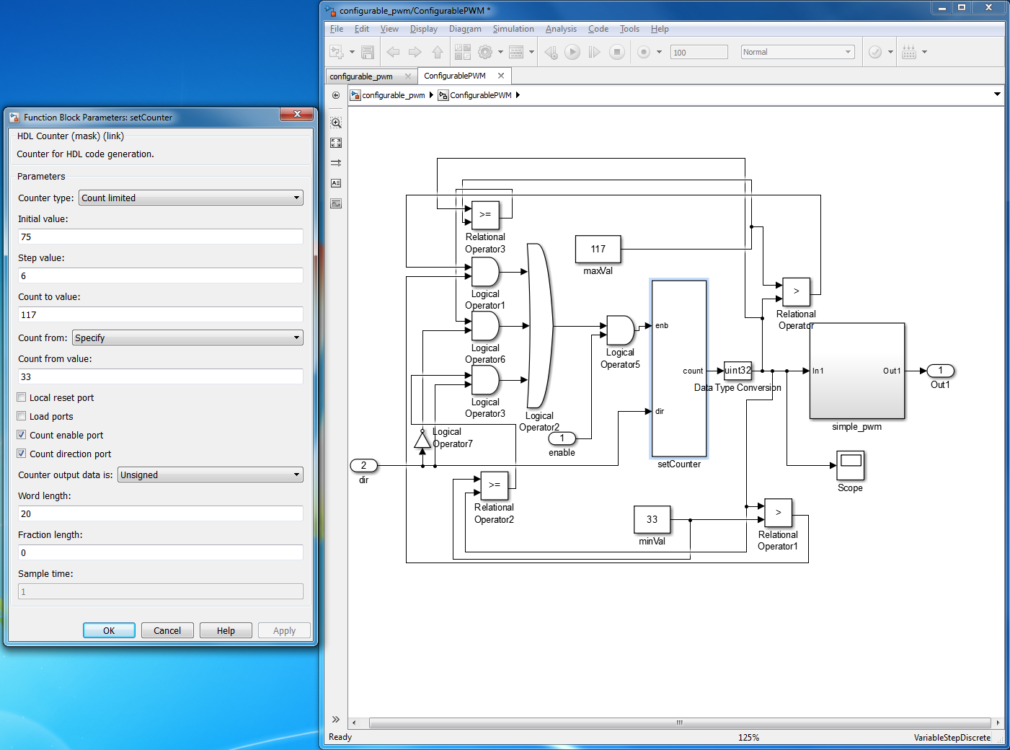

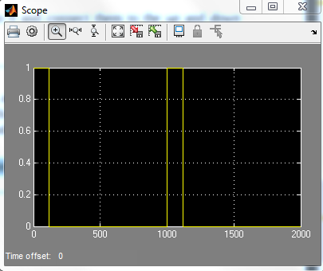

This output of the scope is 1 when the HDL Counter (initial value 0, step value 1, count to value 1000) is less than the setCounter (initial value 75, step value 6, count to value 117, and count from value 33)

# 

# 

# Assignment 2

a)

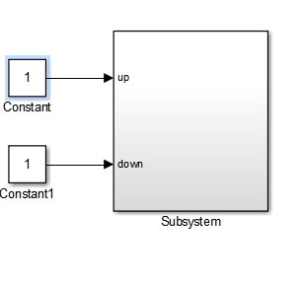

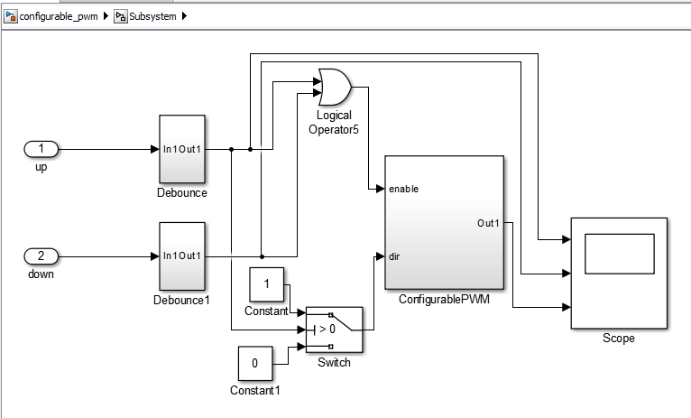

b)

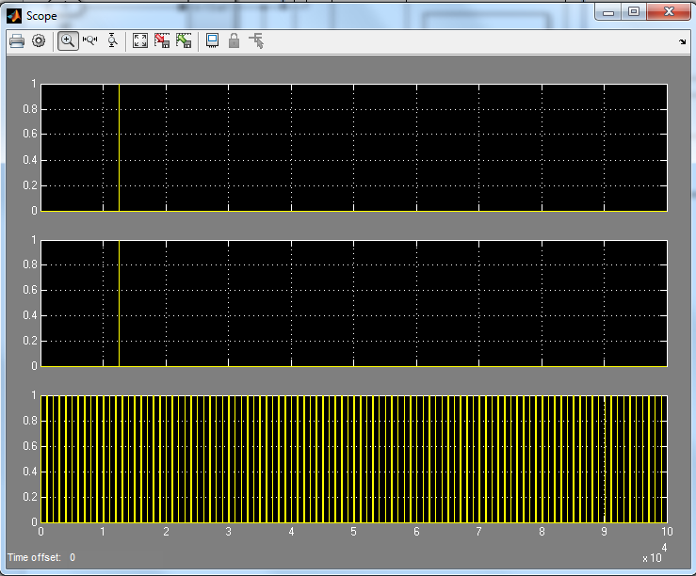

The first two scopes represent the debounce buttons for up and down and they take in a constant of 1, so the button is pressed once which is indicated by the one time it goes up to 1. The third scope represents the ConfigurablePWM represents the PWM signal, which is the design from assignment 1

c) The values are all scaled down by a factor of ${10^{3}}^{}$.

***Up press:***

|  |  |  |
| --- | --- | --- |
| Start | End | Width |
| 1.2012 | 1.2087 | 0.0075 |
| 1.3013 | 1.3094 | 0.0081 |

The difference between the widths is .0006 which is consistent with the step value of 6 and the positive direction.

***Down press:***

|  |  |  |
| --- | --- | --- |
| Start | End | Width |
| 1.2012 | 1.2087 | 0.0075 |
| 1.3013 | 1.3082 | .0069 |

The difference between the widths is -.0006 which is consistent with the step value of 6 and the negative direction.

Assignment 3

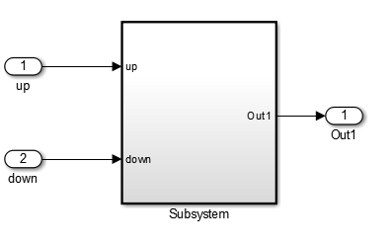

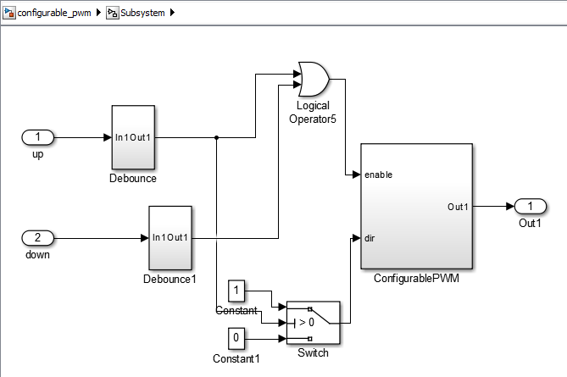

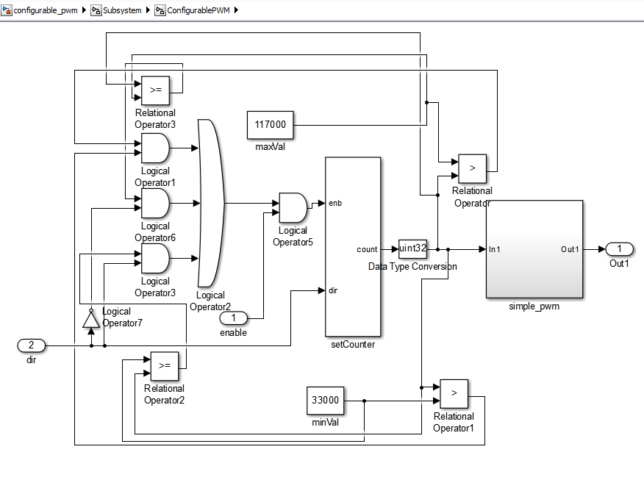

As shown in the video titled “assignment3”, when we press push button up, the wrist moves up. When we press push button down, the wrist moves down.

Assignment 4

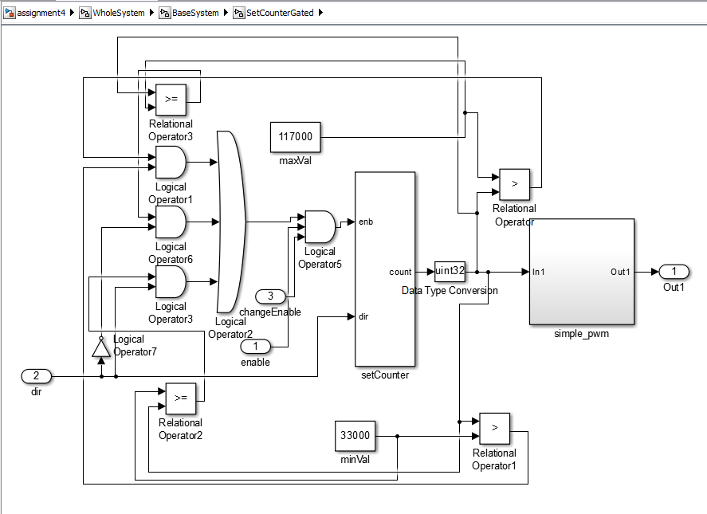

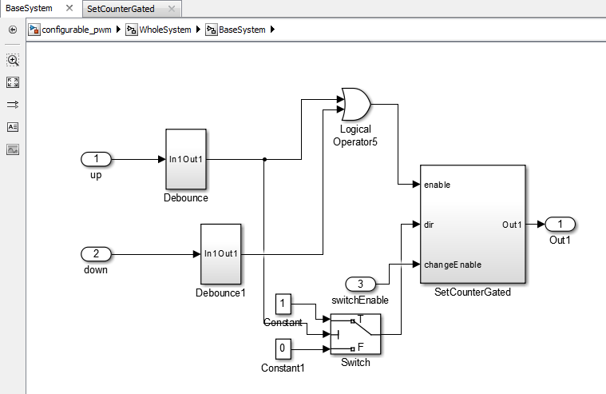

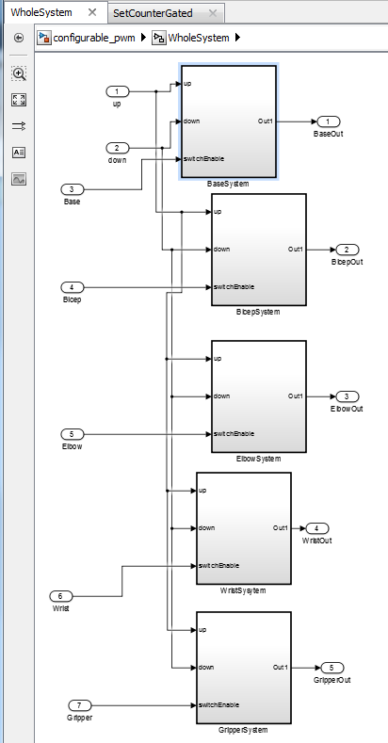

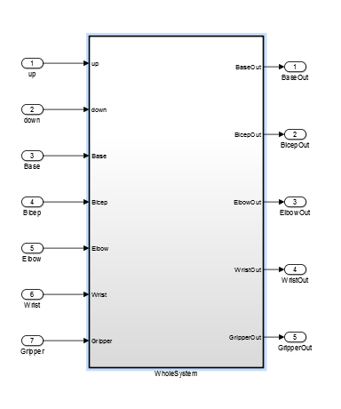

In the design, each of the switches share the same up and down input. However, each of the servos (base, bicep, elbow, wrist, and gripper) have their own switches. changeEnable has been added as an input for the AND gate of each of the enables. This causes the up and down button presses to only work for that servo if the switch for that servo is enabled.

As shown in the video titled “assignment4”,

-I first press up and down with all the switches off and nothing happens

-I then turn on switch0 which is the Base and press up and down and the Base moves accordingly.

-I then turn on switch1 which is the Bicep and press up and down and the Bicep moves accordingly.

-I then turn on switch2 which is the Elbow and press up and down and the Elbow moves accordingly.

-I then turn on switch3 which is the Wrist and press up and down and the Wrist moves accordingly.

-I then turn on switch4 which is the Gripper and press up and down and the Gripper moves accordingly.

I then turn on switch0 which is the Base and switch1 which is the Bicep and press up and down and the Base and Bicep both move accordingly in sync

I then turn on switch0-switch4 which are the switches for all the servos and press up and down and all of the servos move together accordingly.